Emerging Minds Kick Off Meeting - Oxford
2pm – 4.30pm 16 December 2019

Ark T Centre, Crowell Road, Cowley, Oxford, OX4 3LN
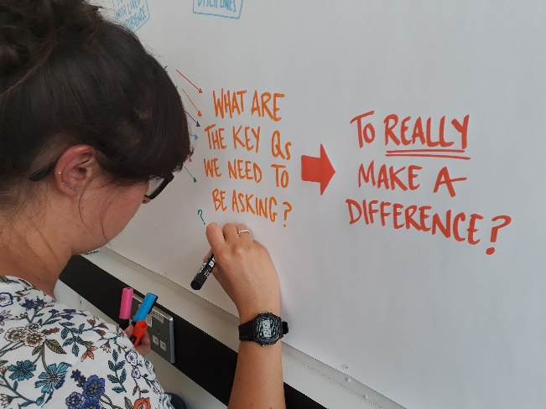

The Emerging Minds network would like to invite you to a kick off meeting hosted by Professor Cathy Creswell of the University of Oxford.

Emerging Minds is a mental health research network funded by UK Research & Innovation (UKRI) with the aim of encouraging research across sectors and disciplines. We want to reduce the prevalence of mental health problems amongst children and young people through mental health promotion, prevention and early treatment.

The Emerging Minds network has a fund of £500,000 to share to enable research collaborations. We have prioritised 4 research challenges from the questions that young people, families, practitioners and policy makers have told us are most important and pressing. The purpose of the meeting and workshops is to kick start the next stage of the project.

The objectives of the event are:
- To share more details about the Emerging Minds funding calls to be launched in autumn 2019.
- To showcase inspiring examples of relevant research
- To facilitate discussions around possible collaborations to address the Emerging Minds research challenges.

We will also be highlighting the opportunities offered by the other UKRI funded mental health research networks.

Festive refreshments are included and you can register for your free place on Eventbrite.

Please do email us at info@emergingminds.org.uk if you have any questions or to find out more.

