Emerging Minds Kick Off Meeting - Manchester
2.15pm – 4.45pm 25 November 2019

The Curve, Greater Manchester Mental Health NHS Foundation Trust,

Prestwich, M25 3BL
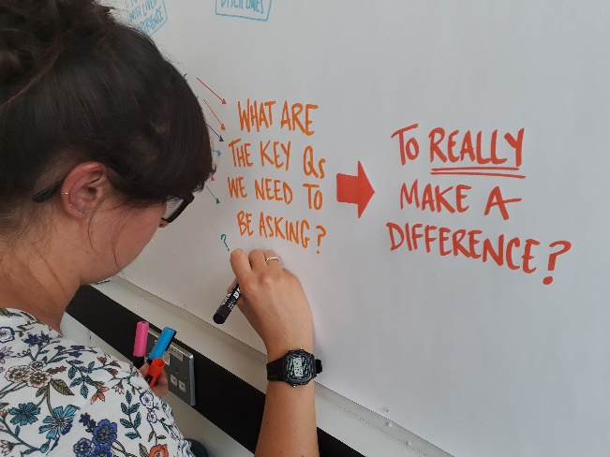

The Emerging Minds network would like to invite you to a kick off meeting hosted by Dr Sophie Parker from the Youth Mental Health Research Unit and Dr Caroline Jay from the University of Manchester.

Emerging Minds is a mental health research network funded by UK Research & Innovation (UKRI) with the aim of encouraging research across sectors and disciplines. We want to reduce the prevalence of mental health problems amongst children and young people through mental health promotion, prevention and early treatment.

The Emerging Minds network has a fund of £500,000 to share to enable research collaborations. We have prioritised 4 research challenges from the questions that young people, families, practitioners and policy makers have told us are most important and pressing. The purpose of the meeting and workshops is to kick start the next stage of the project.

The objectives of the event are:
- To share more details about the Emerging Minds funding calls to be launched in autumn 2019.
- To showcase inspiring examples of relevant research
- To facilitate discussions around possible collaborations to address the Emerging Minds research challenges.

We will also be highlighting the opportunities offered by the other UKRI funded mental health research networks.

Spaces are limited and you can register for your free place on Eventbrite.

Please do email us at info@emergingminds.org.uk if you have any questions or to find out more.

